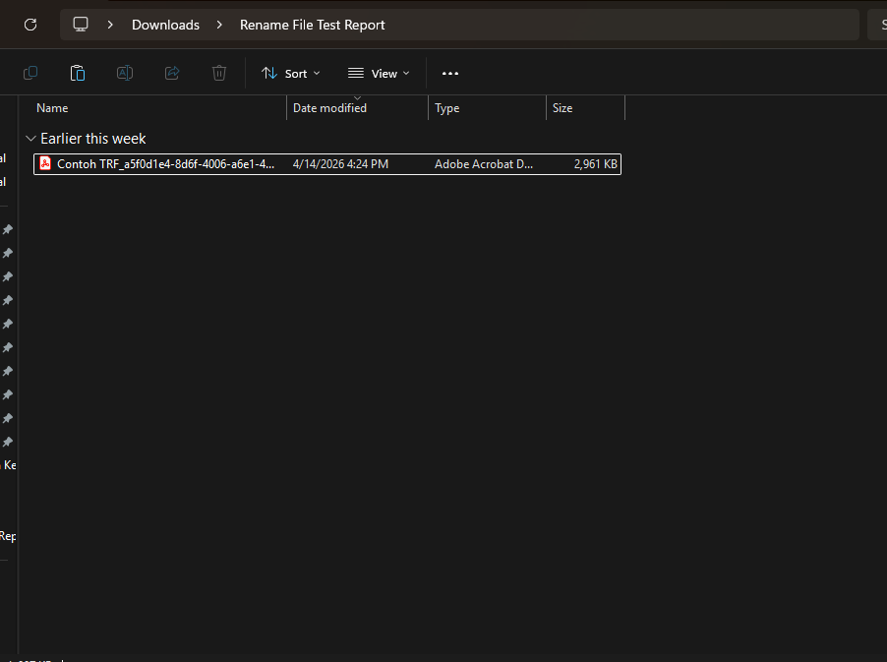

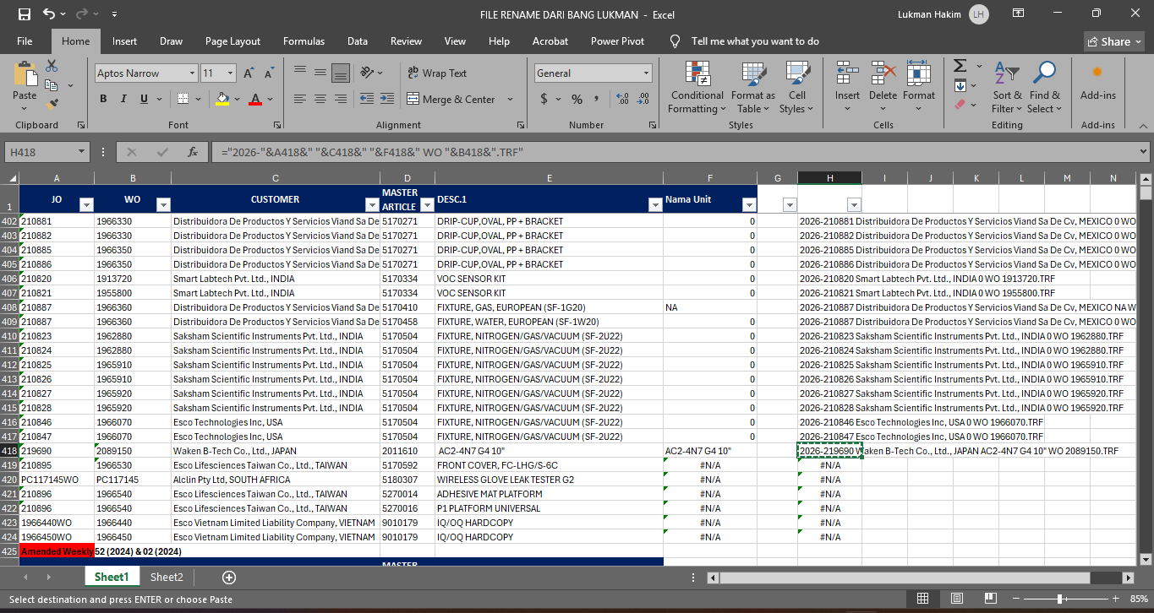

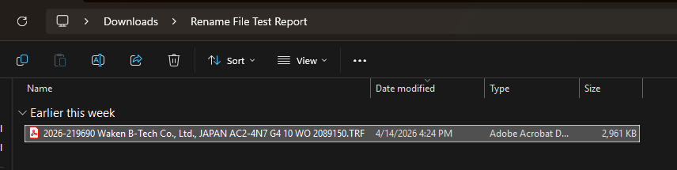

Role/Position
File Creator

Publication Link
-

Artwork/Project Description
1. Problem Understanding
In the workplace, one of the recurring administrative tasks involves renaming TRF (Travel Record Form) files to follow a standardized naming format. The required format is as follows:
(TRF Year)-(Job Order Number) (Customer Name) (Unit Name) WO (Work Order Number).TRF
Under the previous method, the operator had to open two files simultaneously, which are:
- the TRF file and
- the Rename Database
and manually copy each variable one by one:
- Year | - Job Order | - Customer Name | - Unit Name | - Work Order Number
into a search bar before assembling the final file name. Approximately took 10 to 13 seconds/file to rename. This process was highly repetitive, error-prone, and time-consuming, especially when handling a large volume of files in a single session.

2. Research & Solution Design
To cut down processing time, I explored how the existing spreadsheet infrastructure could be leveraged. The key insight was that all necessary naming variables were already stored in the Main Database, they simply needed to be consolidated and pre-formatted. By using Excel formulas (specifically VLOOKUP and string concatenation), a fully assembled file name could be generated automatically, requiring the operator to perform only one search and one copy-paste action per file.
I analyzed the existing data structure within the Main Database and identified the relevant columns needed for the renaming process:
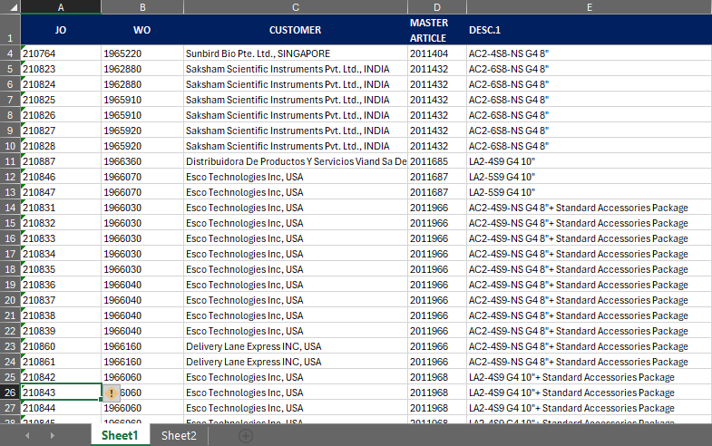  Pic 2.1. Sheet 1 view | 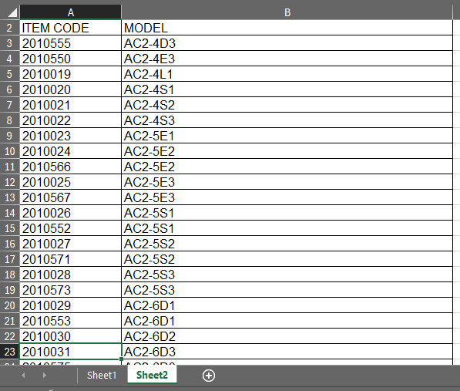  Pic 2.2. Sheet 2 view

Sheet 1 — Required variables:
- JO (Job Order Number)
- WO (Work Order Number)
- Customer
- Master Article
- Desc 1
However, the unit names in the Desc 1 column did not follow the standardized naming convention. A second reference sheet was required to resolve this:
Sheet 2 — Reference for unit name standardization:
- Item Code
- Model
By linking both sheets, I was able to map each Master Article (Item Code) to its correct standardized unit name using a VLOOKUP formula.

3. Solution Implementation
Step 1 — Creating the Unit Name Column (VLOOKUP)
A new column, "Unit Name" was added to Sheet 1 using the VLOOKUP function to retrieve the correct unit name from Sheet 2 based on the Master Article value:
=VLOOKUP(master_article_cell, Sheet2!A:B, 2, 0)
For example, Master Article code 2010555 maps to unit name AC2-4D3. This ensures all unit names are standardized before being used in the final file name. Note: You can see at the red rectangle, there are difference names between those 2 columns
  Pic 3.1. Before implement unit name column formula | 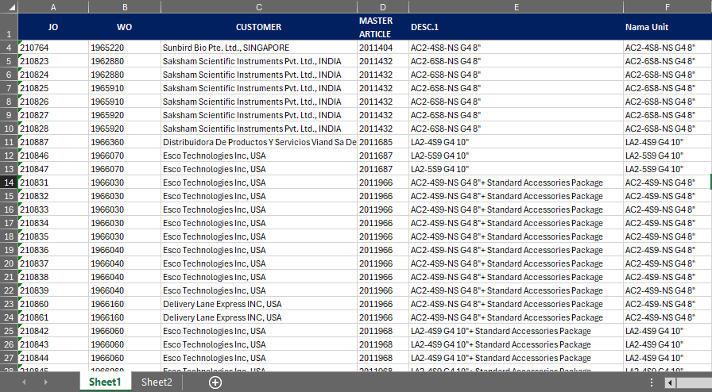  Pic 3.2. After implement unit name column formula

Step 2 — Building the Rename Formula
With all variables available in one sheet, a concatenation formula was constructed to automatically generate the complete standardized file name:
="(TRF Year)-"&(Job Order)&" "&(Customer)&" "&(Unit Name)&" WO "&(Work Order)&".TRF"
Expected output example:
2025-210764 Sunbird Bio Pte. Ltd., SINGAPORE AC2-4S8-NS G4 8" WO 1965220.TRF
  Pic 3.3. Before adding concatenation formula (column) | 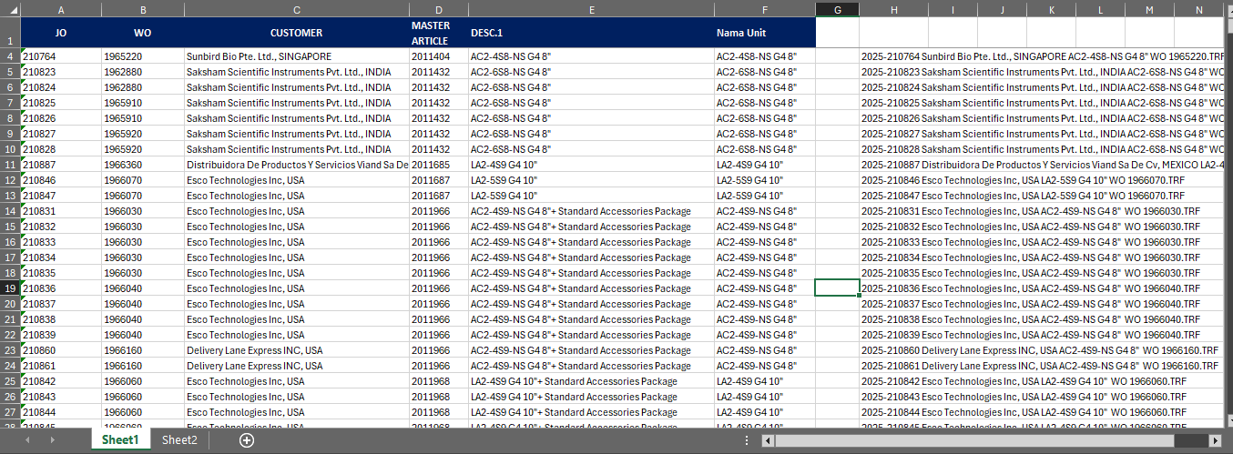  Pic 3.4. After adding concatenation formula (column)
4. New Workflow (Step-by-Step)
Materials needed:
- A folder containing the TRF files to be renamed
- The Rename Database file (prepared in advance)
Process:
- Open one of the TRF files to retrieve its Job Order (JO) number or you can use preview pane feature so you don’t have to open the file. This serves as the Primary Key (PK).
- Open the Rename Database file.
- In the Rename Database, search for the JO number. It is recommended to select the JO Number column (Column A) before searching to speed up the process.
- Copy the complete file name from Column H (the Result column).
- Paste the copied name onto the TRF file to rename it. Done.
Note: If the JO number is not found in the database, the database may not have been updated yet. Request an update from the admin (Supervisor) before proceeding.
Sample Case:
- Open TRF folder.

Pic 4.1. Open TRF folder.
- Open file TRF to retrieve the JO number (or you can use preview pane feature).
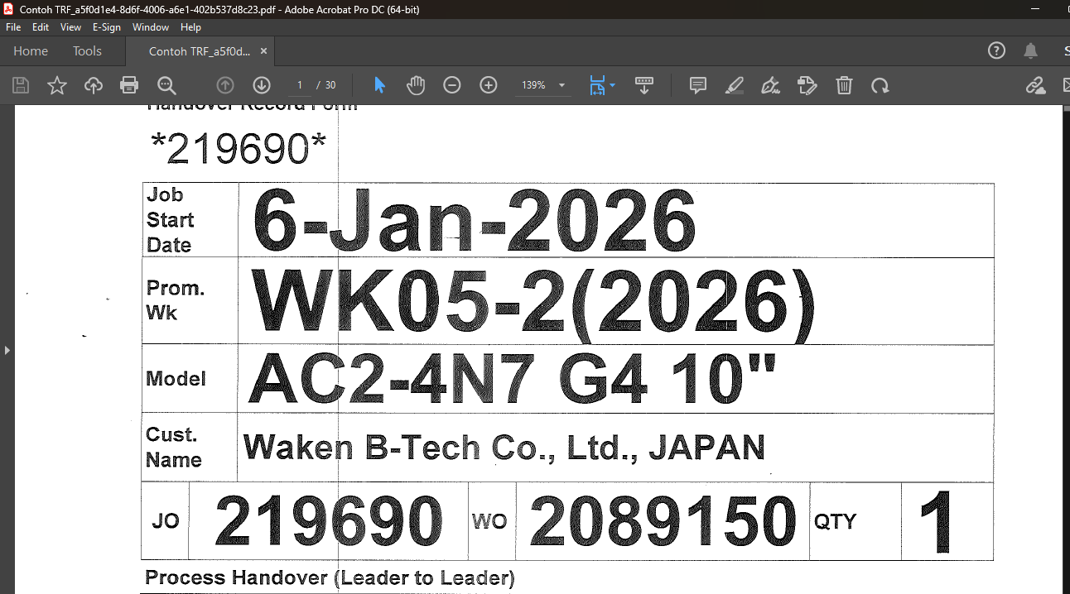
Pic 4.2. Open file TRF to retrieve the JO number
  - Use search feature to type the JO number.
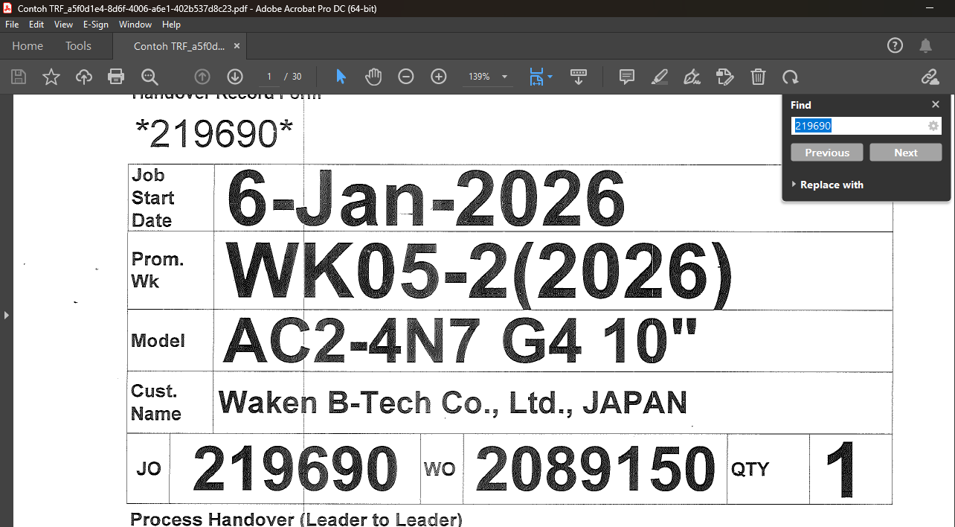
Pic 4.2.1. Use search feature to type the JO number.
- In the Rename Database, search for the JO number. It is recommended to select the JO Number column (Column A) before searching to speed up the process.
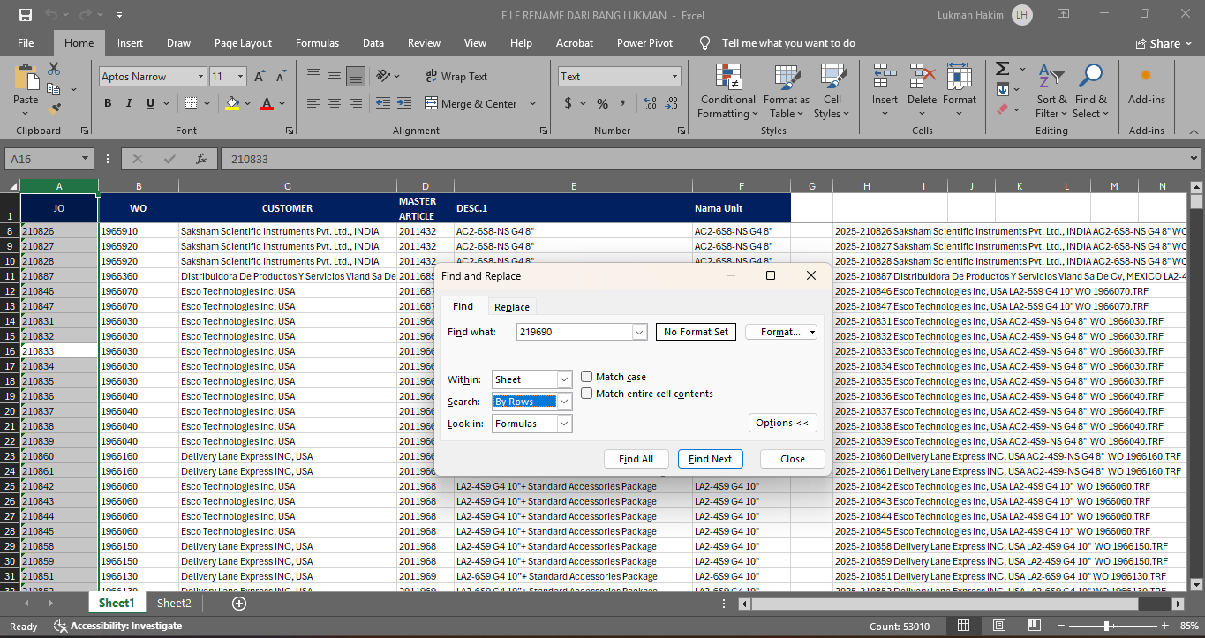
Pic 4.3. Search for the JO number in the Rename Database
- Copy the complete file name from Column H (the Result column).
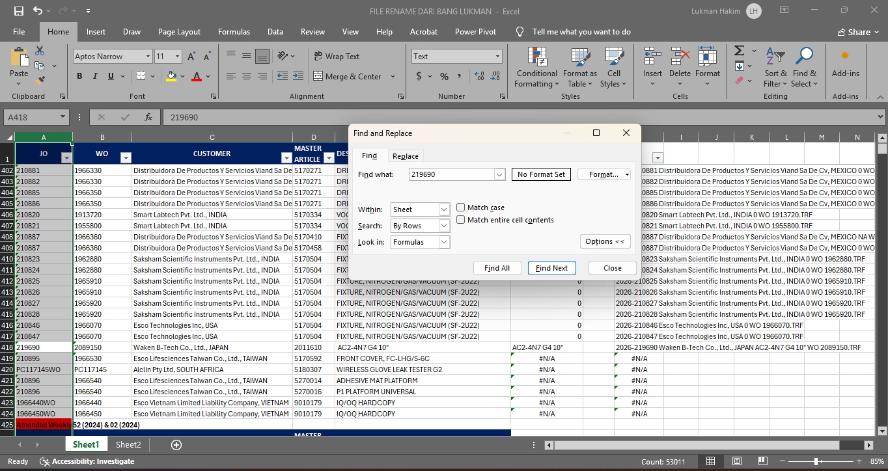  Pic 4.4. Search JO Number process |   Pic 4.5. Click the formula
- Paste the copied name onto the TRF file to rename it. Done.
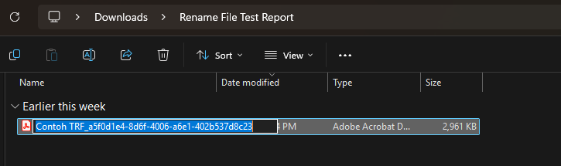  Pic 4.6. Rename the file |   Pic 4.7. Rename process is done
5. Before vs. After Comparison
Old Method | New Method
- Open 2 files simultaneously (Database and TRF file)  - Copy each variable one by one (Year, JO, Customer, Unit, WO)  - Assemble manually in search bar  - Highly repetitive and error-prone | - Open 1 file (Rename Database)  - Search by JO number  - Copy the pre-assembled name from Column H  - Faster, standardized, and consistent
6. Outcome & Impact
The new method significantly reduced the time and effort required for TRF file renaming. By centralizing all naming variables into a single, pre-formatted column, the operator only needs to perform a single search and a single copy-paste action per file. Measurable result: the time to rename a single TRF file was reduced from approximately 10–13 seconds (old method) to 4–5 seconds (new method), a reduction of roughly 60% per file. Across a high-volume session, this improvement translates to substantial time savings while also eliminating the risk of manual assembly errors. For example, in a session involving 100 files, the old method required approximately 19 minutes, while the new method completes the same workload in under 8 minutes — saving nearly 12 minutes per session. The solution required no additional software and could be adopted immediately by any team member familiar with basic spreadsheet operations.

